Calculus AB Key
Limits and Continuity
A calculator may not be used.
I. Multiple Choice
Choose the best answer for each of the following questions.
Questions 1-3, are based on the function $f$ shown in the graph and defined below:

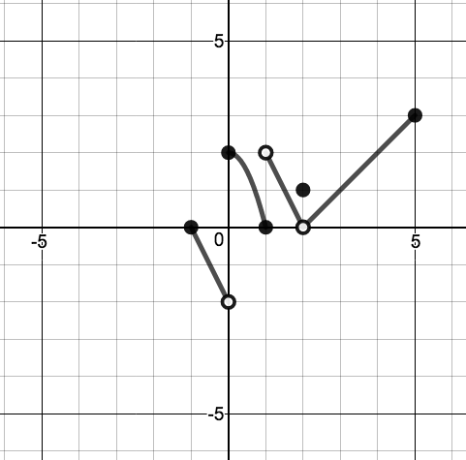

$$f\left(x\right)=\left\{\begin{aligned}-2x-2, -1≤&x<0 \\ -2x^{2}+2, 0≤&x≤1 \\ -2x+4, 1<x<2 \\ 1, x=2 \\ x-2, 2<x≤5\end{aligned}\right.$$

1. The function $f$is defined on [-1,5]

A. if $x≠0$ B. if $x≠1$ C. if $x≠2$ D. for each $x$ in [-1,5]

The function is not continuous but since it passes the vertical line test is is defined for each value of $x$ in the given domain. (D)

2. The function $f$ has a removable discontinuity at

A. $x=0$ B. $x=1$ C. $x=2$ D. none of these

A removable discontinuity occurs when there is a point discontinuity that can be “filled” so the removeable discontinuity is at $x=2$. (C)

3. The function $f$is continuous over which of the following intervals?

A. $-1≤x≤0$ B. $0≤x≤1$ C. $1≤x≤2$ D. $2≤x≤5$

The function is continuous only over the closed interval [0,1] for all other options given have an endpoint that should not be included. (B)

- Find the limit.
$$\lim_{x→∞}{\frac{\sqrt{{16x}^{6}+9}}{ 9x^{3}+4}}$$

A. $\frac{4}{9}$ B. $\frac{4}{3}$ C. $\frac{16}{9}$ D. infinite

Evaluate the degree of the numerator and denominator, take lead coefficients of each since the degrees are the same.: $\frac{4}{9}$ (A)

- Evaluate the limit , if it exists:
$$\lim_{x→15}{\frac{\sqrt{x+1}-4}{x-15}}$$

A. $-1$ B. $-\frac{1}{8}$ C. 0 D. $\frac{1}{8}$
. Rationalize the numerator, cancel out the denominator $: \frac{1}{8}$ (D)

- Consider the following graphs of $f$ and $g$ given below.
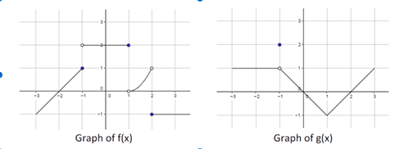

Find: $\lim_{x→2}{[f\left(x\right)g\left(x\right)]}$

A -1 B. $0$ C. 1 D. Does not exist

This question is commonly missed by students; in order to solve this properly one must consider the product of the limit as x is approaching 2 both on the left and on the right. Since $\lim_{x→2^{-}}\left[f\left(x\right)g\left(x\right)\right]=1∙0=0$
And $\lim_{x→2^{+}}\left[f\left(x\right)g\left(x\right)\right]=-1∙0=0$ the limit for the left and right are equal
Therefor $\lim_{x→2}[{f\left(x\right)g(x)]=0}$ (B)

- Find the limit.
$$\lim_{x→-\frac{π}{2}}{ \frac{\frac{π}{2}-x}{\cos{(x+\frac{π}{2})}}}$$

A. $-\frac{π}{2}$ B. $0$ C. $π$ D. $\frac{π}{2}$

Use direct substitution: $π$ (C)

8. Given the function: $f\left(x\right)=\left\{\begin{aligned}\cos{2x, x≥\frac{π}{2}} \\ x+k, x<\frac{π}{2}\end{aligned}\right.$ ,
what value of k will make this piecewise function continuous?

A. $-1-\frac{π}{2}$ B. $-1+\frac{π}{2}$ C. $1-\frac{π}{2}$ D. $1+\frac{π}{2}$.

$\cos{2x=x+\frac{π}{2}} when x=\frac{π}{2} : -1-\frac{π}{2}$ (A)

9. Let $f\left(x\right)=\left\{\begin{aligned}\frac{x^{2}-9}{x-3}, if x≠3 \\ 2 if x=3\end{aligned}\right.$ which of the following statements is (are) true?
$$\underset{ x→3}{I. lim}{f(x)}exists.$$
$II. f\left(3\right) exists.$
$$III. f(x) is continuous at x=3$$

A. I only B. II only C. III only D. I and II

Only the 1st and 2nd statements are true.
Since $\lim_{ x→3}{f(x)≠f(3)}$ the function is not continuous at $x=3.$ (D)

10. $G(x)$ is a continuous function on a closed interval $\left[2,5\right]$, where
$G(2)≤C≤G(5)$ and $k$ is in the closed interval $\left[2,5\right]$, then which of the following statements must be true?

A. $G(k) =\frac{g\left(5\right)+g(2)}{2}$
B. $G(k) =\frac{g\left(5\right)-g(2)}{2}$
C. $There is at least one value k such that G\left(k\right)=C.$
D. $There is only one value k such that G\left(k\right)=C.$
The conditions given in the question are those required for the intermediate value theorem, therefor the third statement, which is the conclusion of that theorem, is the correct one. (C)

11. Let $f\left(x\right)=\frac{x+1}{4\left|x+1\right|}$ , which of the following statements is true?
A. $f(x)$ has a jump discontinuity at $x=-1$
B. $f(x)$ has a removable discontinuity at $x=-1$
C. $f(x)$ has a vertical asymptote at $x=-1$
D. $\lim_{x→-1}{f\left(x\right)=\frac{1}{4}}$
$\lim_{x→-1^{-}}{f\left(x\right)=-\frac{1}{4}}$ and $\lim_{x→-1^{+}}{f\left(x\right)=\frac{1}{4}}$, so there is a jump discontinuity. (A)

12. For which of the following pairs of functions for $p$ and $q$ is $\lim_{x→∞}{\frac{p(x)}{q(x)}}$ infinite?
A. $p\left(x\right)=3x^{2}+4x$; $q\left(x\right)=2x^{3}+1$
B. $p\left(x\right)=x^{3}+4$; $q\left(x\right)=2x^{3}+3$
C. $p\left(x\right)=2^{x}$; $q\left(x\right)=3^{x}$
D. $p\left(x\right)=3x^{4}+2x$; $q\left(x\right)=x^{3}+2$

In order for a rational function to have a infinite limit as $x→∞$, the degree of the numerator must be larger then the degree of the denominator. (D)

II Free Response.

13. The function $f$ is defined by $f\left(x\right)=\sqrt{100-x^{2}}$for $-10≤x≤10$.

Let $h$ be the function defined by $h\left(x\right)=\left\{\begin{aligned}f\left(x\right), for-10≤x≤8 \\ x+2, for 8<x≤10\end{aligned}\right.$

- Determine if $h(x)$ is a continuous function over the closed interval [-10,10].
Use the definition of continuity to explain your answer.

Over the interval [-10,10] the only possible discontinuity is at $x=8$ where the piecewise function changes.  $\lim_{x→8^{+}}{h\left(x\right)=6}$ and $\lim_{x→8^{-}}{h\left(x\right)=10}$.  Since the left-sided limit and the right-sided limit are not equal, $h(x)$ is not continuous. | 1: identifies possible point(s) of  discontinuity  3 1: finds left and right sided limits  1: uses definition of continuity for  conclusion.

14. The function$f$ is defined as $f\left(x\right)=-2x^{2}+2$, the function $g$ is defined
as $g\left(x\right)=\frac{1}{x-1}$, let $p\left(x\right)=f(x)∙g(x)$, and let $h$ be the function defined by $h\left(x\right)=\left\{\begin{aligned}p(x) for -2≤x<1 \\ f\left(x\right)-k, for x≥1\end{aligned}\right.$
where $k$ is a constant.

- Find the limit of $p(x) as x$ approaches 1. Show all work that leads to your answer. Is $p(x)$ continuous over the closed interval of [-2,2]? Explain.
$$\lim_{x→1}{p}\left(x\right)=\frac{-2x^{2}+2}{x-1}=\frac{-2\left(x^{2}-1\right)}{x-1}$$  $$\lim_{x→1}{p}\left(x\right)=\frac{-2(x-1)(x+1)}{x-1}$$  $$\lim_{x→1}{p}\left(x\right)=-2\left(x+1\right)=-2\left(2\right)=-4$$  Since $(x-1)$ was factored out there is a hole in the $p(x)$ at that point. Therefor the function is not continuous over the given closed interval of [-2,2]. | 1: $\lim_{x→1}{p\left(x\right)=-4}$  3 1: work that leads to answer  1: Conclusion with reason
b) What value of $k$ will make $h(x)$ continuous at $x=1?$ Justify your answer.
From part a above :  $\lim_{x→1}{p}\left(x\right)=-4$,  $$-4=\left(-2x^{2}+2\right)-k=\left(-2\left(1\right)+2\right)-k$$  $$-4=0-k$$  $$k=4$$ | 1: uses limit from part a  2 1: solves for k

